Copyright for test papers and marking guides remains with West Australian Test Papers.
Test papers may only be reproduced within the purchasing school according to the advertised Conditions of Sale.
Test papers should be withdrawn after use and stored securely in the school until Friday July 5th 2019.


MATHEMATICS
SPECIALIST
UNIT 1

Semester One

2019

SOLUTIONS

Calculator−free Solutions

1.
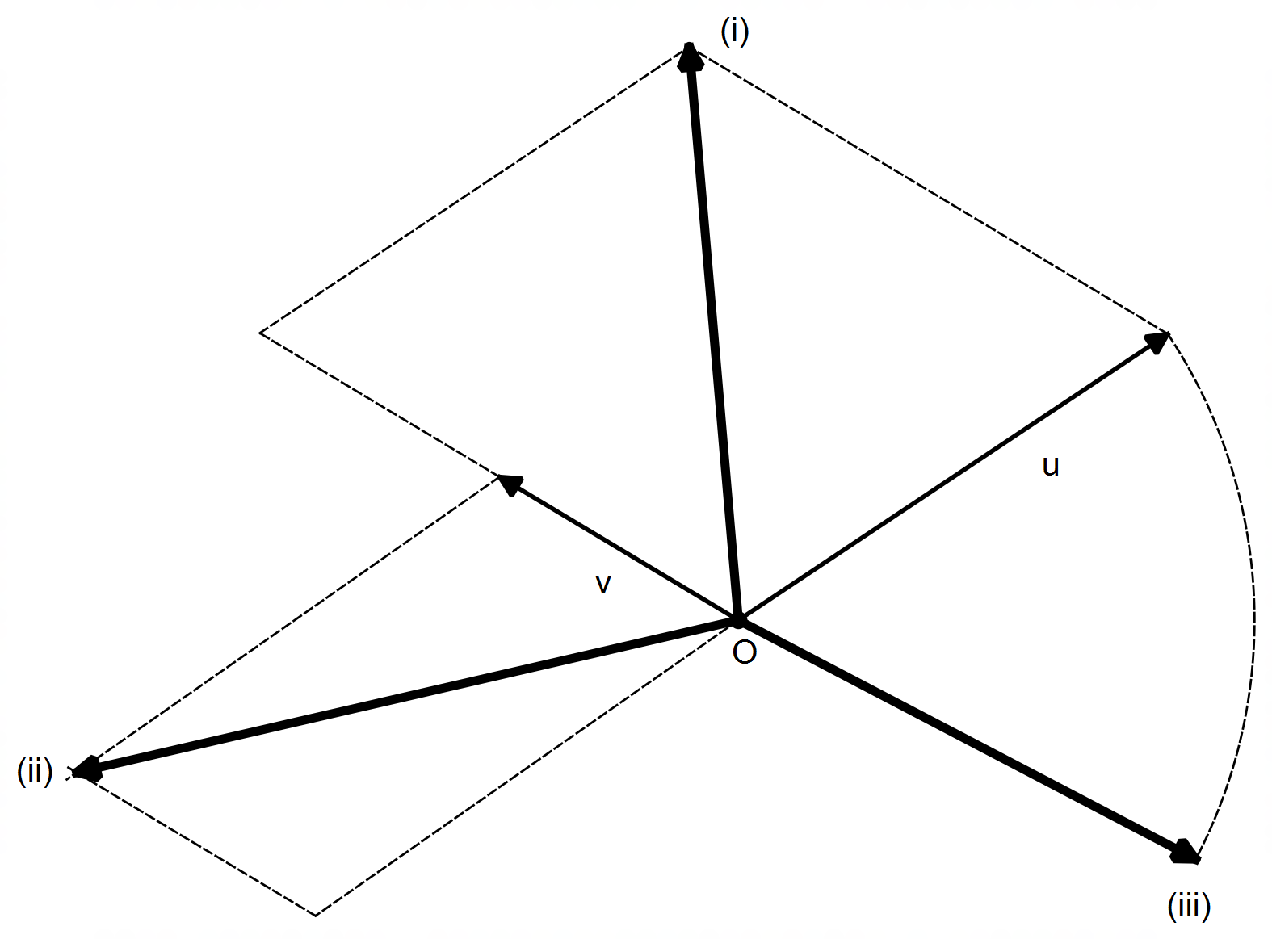
parallelogram with 2v and u as sides

parallelogram with v and –u as sides

vector u in the direction of –v with magnitude |u|

[6]

2. (a) (i) $\left(\begin{matrix}3 \\ -5\end{matrix}\right)=k\left(\begin{matrix}4 \\ α\end{matrix}\right)$
$∴k=\frac{3}{4} → α=-\frac{5}{k}=-\frac{20}{3}$

(ii) $\left(\begin{matrix}4 \\ α\end{matrix}\right)∙\left(\begin{matrix}1 \\ 1\end{matrix}\right)=0$
$∴4+α=0 → α=-4$

(iii) $\vec{PQ}=\left(\begin{matrix}1 \\ α+5\end{matrix}\right)$
since the x–coordinate is already 1 unit in length, then
the y–coordinate must be zero.
$∴α=-5$

(iv) PQ as base ⇒ |OP| = |OQ|
$\left|\begin{matrix}3 \\ -5\end{matrix}\right|=\left|\begin{matrix}4 \\ α\end{matrix}\right| → \sqrt{34}=\sqrt{16+α^{2}}$
$∴α^{2}=18 → α=±3\sqrt{2}$

2. (b) (i) Solving simultaneously (any method, elimination shown below):

$\begin{matrix}u \\ v\end{matrix} \begin{matrix}= \\ =\end{matrix} \begin{matrix}-6i \\ 2i\end{matrix} \begin{matrix}-2j \\ +3j\end{matrix} \begin{matrix}×3 \\ ×2\end{matrix} → \begin{matrix}3u \\ 2v\end{matrix} \begin{matrix}= \\ =\end{matrix} \begin{matrix}-18i \\ 4i\end{matrix} \begin{matrix}-6j \\ +6j\end{matrix} ↓\left(+\right)$

$∴ 3u+2v=-14i → i=-\frac{3}{14}u-\frac{1}{7}v$

similarly (or by substitution):

$\begin{matrix}u \\ v\end{matrix} \begin{matrix}= \\ =\end{matrix} \begin{matrix}-6i \\ 2i\end{matrix} \begin{matrix}-2j \\ +3j\end{matrix} \begin{matrix}×1 \\ ×3\end{matrix} → \begin{matrix}u \\ 3v\end{matrix} \begin{matrix}= \\ =\end{matrix} \begin{matrix}-6i \\ 6i\end{matrix} \begin{matrix}-2j \\ +9j\end{matrix} ↓\left(+\right)$

$∴ u+3v=7j → j=\frac{1}{7}u+\frac{3}{7}v$

(ii) $r=14\left(-\frac{3}{14}u-\frac{1}{7}v\right)+7\left(\frac{1}{7}u+\frac{3}{7}v\right)$

$∴r=-2u+v$ [14]

3. (a) (i) $20!-18!=20×19×18!-18!$
$=\left(20×19-1\right)×18!$
$=\left(380-1\right)k=379k$

(ii) $\frac{{}_{ }^{20}{P_{3}}}{{}_{ }^{21}{C_{3}}}=\frac{20!}{3!}÷\frac{21!}{3!×18!}$
$=\frac{20!}{3!}×\frac{3!×18!}{21×20!}=\frac{k}{21}$

(b) RHS $=\left(\begin{matrix}n \\ n-r\end{matrix}\right)=\frac{n!}{\left(n-r\right)!×\left[n-\left(n-r\right)\right]!}$
$=\frac{n!}{\left(n-r\right)!\left[r\right]!}$
$=\left(\begin{matrix}n \\ r\end{matrix}\right)=$ LHS [6]

4. (a) If $m<1$, then $m>m^{2}$.
It is NOT always true because it does not work for negatives.
e.g. $m=-2<1 → m^{2}=4>m ∴$ false
The converse is always true for $0<m<1$

(b) If the parallelogram is not a rectangle, then it does not have congruent diagonals.
Yes it is always true as only squares and rectangles have congruent diagonals.

(c) For all rational numbers , there exists two integer numbers $a$ and $b$
such that $p$ is the quotient of $a$ and $b$. [8]

5. (a) (i) $2^{6}=1+6+15+20+15+6+1=64$
(ii) ${11}^{5}={\left(10+1\right)}^{5}$
$={10}^{5}+5×{10}^{4}+10×{10}^{3}+10×{10}^{2}+5×10+1^{5}$
$=100 000+50 000+10 000+1 000+50+1$
$=161051$

(b) (i) $x=3$ since ${}_{ }^{6}{C_{3}}=20$
(ii) $x=7$ since ${}_{ }^{7}{C_{5}}=21$
(iii) $x=8$ since ${}_{ }^{8}{C_{2}}={}_{ }^{8}{C_{6}}$

(c) ${\left(2x-y\right)}^{5}$
$={\left(2x\right)}^{5}+5{\left(2x\right)}^{4}{\left(-y\right)}^{1}+10{\left(2x\right)}^{3}{\left(-y\right)}^{2}+10{\left(2x\right)}^{2}{\left(-y\right)}^{3}+5{\left(2x\right)}^{1}{\left(-y\right)}^{4}+{\left(-y\right)}^{5}$
$=32x^{5}-80x^{4}y+80x^{3}y^{2}-40x^{2}y^{3}+10xy^{4}-y^{5}$

(d) (i) ${}_{ }^{8}{C_{5}}=56$
(ii) ${}_{ }^{2}{C_{2}}×{}_{ }^{6}{C_{3}}=1×20=20$
(iii) ${}_{ }^{3}{C_{2}}×{}_{ }^{5}{C_{3}}+{}_{ }^{3}{C_{3}}×{}_{ }^{5}{C_{2}}$
$=3×10+1×10=30+10=40$ [13]

6. (a) $\vec{AD}=\frac{2}{5}\vec{AB}=\frac{2}{5}\left(b-a\right)$
$\vec{CD}=\vec{CO}+\vec{OA}+\vec{AD}=-\frac{1}{2}b+a+\frac{2}{5}\left(b-a\right)$
$∴\vec{CD}=\frac{3}{5}a-\frac{1}{10}b$

(b) $\vec{OC}+\vec{CE}=\vec{OE} → \vec{OC}+β\vec{CD}=α\vec{OA}$ given
$∴\frac{1}{2}b+β\left(\frac{3}{5}a-\frac{1}{10}b\right)=αa$
$×10 → 5b+6βa-βb=10αa$
$→ \left(6β-10α\right)a=\left(β-5\right)b$
since $a$ and $b$ are non–parallel, then:
$β-5=0 → β=5$
$6β-10α=0 → α=\frac{3}{5}β=3$ [6]

Calculator−assumed Solutions

7. (a) ABC collinear ⇒ AB // BC
$\vec{AB}=\left(\begin{matrix}-2 \\ 4\end{matrix}\right)-\left(\begin{matrix}4 \\ -5\end{matrix}\right)=\left(\begin{matrix}-6 \\ 9\end{matrix}\right)$
$\vec{BC}=\left(\begin{matrix}-6 \\ 10\end{matrix}\right)-\left(\begin{matrix}-2 \\ 4\end{matrix}\right)=\left(\begin{matrix}-4 \\ 6\end{matrix}\right)$
$∴\left(\begin{matrix}-6 \\ 9\end{matrix}\right)=k\left(\begin{matrix}-4 \\ 6\end{matrix}\right) → \begin{matrix}k=\frac{-6}{-4}=\frac{3}{2} \\ k=\frac{9}{6}=\frac{3}{2}\end{matrix}$
Since $k$ is unique, then AB // BC and hence ABC collinear.

(b) $\left|AB\right|=\left|\begin{matrix}-6 \\ 9\end{matrix}\right|=3\left|\begin{matrix}-2 \\ 3\end{matrix}\right|$ and $\left|BC\right|=\left|\begin{matrix}-4 \\ 6\end{matrix}\right|=2\left|\begin{matrix}-2 \\ 3\end{matrix}\right|$
$∴AB:BC=3:2$ [5]

8. (a) ∠PFO = 35°
Because ΔOFP is isosceles since |OP| = |OF| = radii

(b) ∠FEP = 55°
Since ∠FOP = 110° from ΔOFP, and the angle at the centre
is double the size of the angle at the edge.

(c) ∠PQF = ∠FEP = 55°
Angles at the circumference within the same segment
are congruent.

(d) ∠CFP = ∠FEP = 55°
The alternate segment theorem

(e) |GC| = |CF| = 11 – |FB| = 11 – 8 = 3 cm
Tangents to a circle from the same external point
are congruent.

(f) |AM|×(|AM| + 2×radius) = |AH|²
|AM|×(|AM|+8) = 5²
|AM|²+8|AM| – 25 = 0
CAS ⇒ |AM| = $-4±\sqrt{41}$
$∴$ |AM| = $\sqrt{41}-4 ≈2.40$ cm only solution [13]

9. (a) (i) Divisible by 3 and 5 = divisible by 15
100 ÷ 15 = 6.6 ⇒ only 6 elements are divisible by 15
Therefore, assuming every other element is chosen
instead of those 6, we need 100 – 6 +1 = 95 elements

(ii) Divisible by 3 = 100 ÷ 3 = 33.3 ⇒ 33 elements
Divisible by 5 = 100 ÷ 5 = 20 elements
Divisible by 3 or 5 = 33 + 20 – 6 = 47 elements
Assuming the other 53 elements are chosen first,
then 53 + 1 = 54 elements must be chosen

(b) Assuming the highest numbers are chosen first:
100 + 99 + 98 + … + 91 + 90 = 955
If 89 is chosen next then the sum exceeds 1000.
Therefore, a maximum of 11 elements must be chosen. [8]

10. (a) $n\left(M∪C\right)=n\left(M\right)+n\left(C\right)-n\left(M∩C\right)$
14 334 = 7 531 + 9 885 – $n\left(M∩C\right)$
$∴n\left(M∩C\right)$ = 3 082 households

(b) $n\left(M∪C∪B\right)=n\left(M\right)+n\left(C\right)+n\left(B\right)$
$- n\left(M∩C\right)-n\left(M∩B\right)-n\left(C∩B\right)$
$+n\left(M∩C∩B\right)$
$∴n\left(M∪C∪B\right)=$ 7 531 + 9 885 + 4 977 – 3 082 – 2 252 – 4 310 + 1 724
= 14 473 that have all three
Therefore, 16 366 – 14 473 = 1 893 households have neither [6]

11. (a) (i) ${}_{ }^{36}{P_{4}}=1 413 720 OR \left({}_{ }^{36}{C_{4}}×4!\right)$
(ii) ${}_{ }^{10}{C_{2}}×{}_{ }^{26}{C_{2}}×4!=351 000$
(iii) ${}_{ }^{5}{C_{1}}×{}_{ }^{34}{P_{2}}×{}_{ }^{4}{C_{1}}=22 440$

(b) II and III

(c) ${}_{ }^{x+1}{P_{3}}={}_{ }^{4}{C_{3}}×{}_{ }^{x}{P_{2}}$
$\frac{\left(x+1\right)!}{\left(x+1-3\right)!}=4×\frac{x!}{\left(x-2\right)!}$
$\frac{\left(x+1\right) × x!}{\left(x-2\right)!}=4\frac{x! }{\left(x-2\right)!}$
$\left(x+1\right)=4 → x=3$
11. (d) LHS $=\frac{n!}{\left(n-2\right)!}+2n×\frac{\left(n-1\right)!}{\left(n-1\right)!}$
$=\frac{n!}{\left(n-2\right)!}×\frac{\left(n-1\right)}{\left(n-1\right)}+\frac{2n!}{\left(n-1\right)!}$
$=\frac{n!×\left(n-1\right)+2n!}{\left(n-1\right)!}=\frac{n!\left(n-1+2\right)}{\left(n-1\right)!}$
$=\frac{n! ×\left(n+1\right) }{\left(n+1-2\right)! }=\frac{\left(n+1\right)!}{\left(n+1-2\right)}={}_{ }^{n+1}{P_{2}}=$ RHS [14]

12. (a) $w=\left(\begin{matrix}-20\cos{10°} \\ -20\sin{10°}\end{matrix}\right)$
Hovering speed $=-w=\left(\begin{matrix}20\cos{10°} \\ 20\sin{10°}\end{matrix}\right)$

(b) (i)
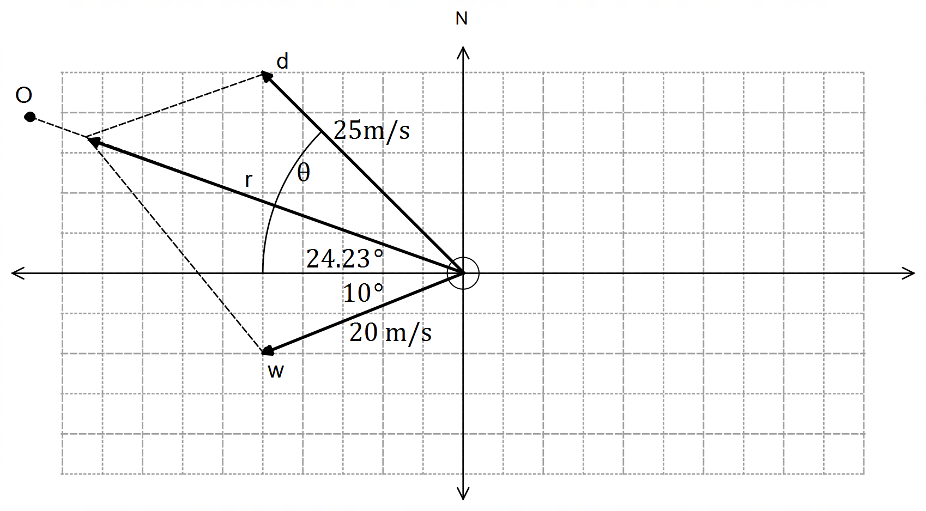

wind vector with correct x-axis
angle
drone vector as a side of
parallelogram and angle θ
resultant vector pointing towards O,
and diagonal of parallelogram

(ii) $w=\left(\begin{matrix}-20\cos{10°} \\ -20\sin{10°}\end{matrix}\right) d=\left(\begin{matrix}-25\cos{θ} \\ 25\sin{θ}\end{matrix}\right) r=\left(\begin{matrix}-r\cos{24.23°} \\ r\sin{24.23}\end{matrix}\right)$

(iii) $\begin{matrix}-r\cos{24.23°} & = -20\cos{10°} & -25\cos{θ} \\ r\sin{24.23°} & = -20\sin{10°} & 25\sin{θ}\end{matrix}$
$∴ \begin{matrix}{25}^{2}\cos^{2}{θ} & = & {\left(r\cos{24.23°+20\cos{10°}}\right)}^{2} \\ {25}^{2}\sin^{2}{θ} & = & {\left(r\sin{24.23°}+20\sin{10°}\right)}^{2}\end{matrix}$
$→{25}^{2}={\left(r\cos{24.23°}+20\cos{10°}\right)}^{2}+{\left(r\sin{24.23°}+20\sin{10°}\right)}^{2}$
CAS $→ r=38.8621$ m/s OR $r=-5.7897$ m/s
$→ θ=46.64°$ OR $θ=2.94°$
$∴time=\frac{d}{v}=\frac{\sqrt{{1200}^{2}+{540}^{2}}}{38.8621}=33.86$ seconds
bearing $=270°+θ=308.86°T$ [14]

13. (a) $\sum{F_{y}}=300\sin{62°}+252\sin{56°}$
$=473.8N$
Since $473.8N<500N$ the machinery is not moving upwards

(b) No horizontal component needed ⇒ $\sum{F_{x}=0}$
$∴400\cos{62°}=x\cos{56°}$
$→x=\frac{400\cos{62°}}{\cos{56°}}=335.82N$

(c) $\sum{F_{y}}=400\sin{62°}+335.82\sin{56°}$
$=631.59N$ [7]

14. (a) (i) Let $n∈N$ with $n=2k+1=$ odd
Then $n^{2}+1={\left(2k+1\right)}^{2}+1$
$=4k^{2}+4k+2$
$=2\left(2k^{2}+2k+1\right)$
Since 2 is a factor, then $n^{2}+1$ is divisible by 2, and
hence the conjecture is true $∀ n∈N$

(ii) Contrapositive statement:
“if $n^{2}+1$ is odd, then $n$ is even.”
Let $n^{2}+1=odd=2k+1$
$∴n^{2}=2k$
$⇒n^{2}=even ⇒ n=even$
Since the contrapositive statement is true $∀ n∈N$,
then the original conjecture is true $∀ n∈N$

(b) A ⇒ B:
If the quadrilateral has two diagonals that intersect at right angles,
then the quadrilateral is a rhombus, which implies it does have
two pairs of parallel sides.
$∴$ A ⇒ B is true

B ⇒ A:
If the quadrilateral has two pairs of parallel sides then it is a parallelogram,
which does not necessarily imply it is a rhombus, and therefore it does not necessarily have diagonals that intersect at right angles.
$∴$ B ⇒ A is false

Therefore, A ⇔ B is a false statement.

(c) Assume that $n$ is odd and $n^{2}$ is even.
Then $∃ k∈N: n=2k+1$
$→n^{2}={\left(2k+1\right)}^{2}=4k^{2}+4k+1$
$=2\left(2k^{2}+2k\right)+1=2m+1=odd$
Since $n^{2}$ is both even and odd simultaneously, this is a contradiction
and therefore the original conjecture must be true $∀ n∈N, n$ even. [15]

15. (a) (i) ${\left|AB\right|}^{2}={\left|OA\right|}^{2}+{\left|OB\right|}^{2}-2\left|OA\right|\left|OB\right|\cos{θ}$
(ii) $\vec{AB}∙\vec{AB}={\left|OA\right|}^{2}+{\left|OB\right|}^{2}-2\left|OA\right|\left|OB\right|\cos{θ}$
LHS $=\left(\vec{OB}-\vec{OA}\right)∙\left(\vec{OB}-\vec{OA}\right)$
$=\vec{OB}∙\vec{OB}-\vec{OB}∙\vec{OA}-\vec{OA}∙\vec{OB}+\vec{OA}∙\vec{OA}$
$={\left|OB\right|}^{2}+{\left|OA\right|}^{2}-2 \vec{OA}∙\vec{OB}$
$∴{\left|OB\right|}^{2}+{\left|OA\right|}^{2}-2 \vec{OA}∙\vec{OB}={\left|OA\right|}^{2}+{\left|OB\right|}^{2}-2\left|OA\right|\left|OB\right|\cos{θ}$
$→-2 \vec{OA}∙\vec{OB}=-2\left|OA\right|\left|OB\right|\cos{θ}$
$→\vec{OA}∙\vec{OB}=\left|OA\right|\left|OB\right|\cos{θ}$ as required

(b) (i) $\left(\begin{matrix}4 \\ 5\end{matrix}\right)∙\left(\begin{matrix}2 \\ -3\end{matrix}\right)=\left|\begin{matrix}4 \\ 5\end{matrix}\right|×\left|\begin{matrix}2 \\ -3\end{matrix}\right|\cos{θ}$
$8-15=\sqrt{41}×\sqrt{13}\cos{θ}$
$∴\cos{θ}=-\frac{7}{\sqrt{533}}$
Since $\cos{θ}<0$ ⇒ $θ$ is obtuse
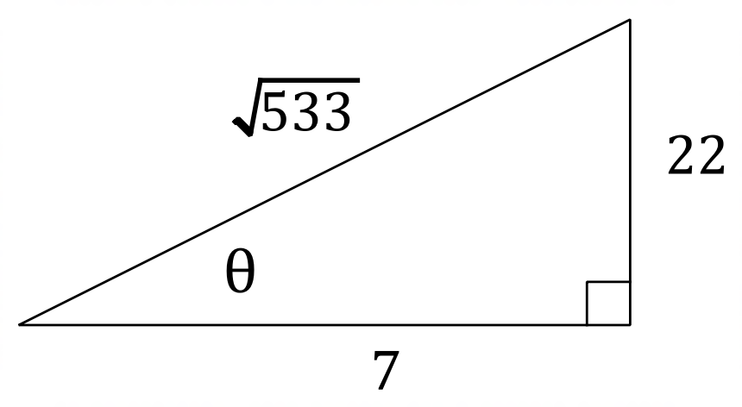
(ii) ⇒ $\sin{θ}=\frac{22}{\sqrt{533}}$

$∴$ area ΔOAB $=\frac{1}{2}\left|OA\right|\left|OB\right|\sin{θ}$
$=\frac{1}{2} \sqrt{41}×\sqrt{13}×\frac{22}{\sqrt{533}}=11$ units² [10]

16. P, Q, R and S are the midpoints of their respective sides:
$\vec{OP}=\left(\begin{aligned}-0.5 \\ 4\end{aligned}\right) \vec{OQ}=\left(\begin{aligned}6 \\ 1.5\end{aligned}\right) \vec{OR}=\left(\begin{aligned}1.5 \\ -4\end{aligned}\right) \vec{OS}=\left(\begin{aligned}-5 \\ -1.5\end{aligned}\right)$
Therefore:
$\vec{PQ}=\left(\begin{aligned}6 \\ 1.5\end{aligned}\right)-\left(\begin{aligned}-0.5 \\ 4\end{aligned}\right)=\left(\begin{aligned}6.5 \\ -2.5\end{aligned}\right)$
$\vec{SR}=\left(\begin{aligned}1.5 \\ -4\end{aligned}\right)-\left(\begin{aligned}-5 \\ -1.5\end{aligned}\right)=\left(\begin{aligned}6.5 \\ -2.5\end{aligned}\right)$
$\vec{PQ}=\vec{SR} ⇒ ∴ \vec{PQ}$ // $\vec{SR}$

$\vec{PS}=\left(\begin{aligned}-5 \\ -1.5\end{aligned}\right)-\left(\begin{aligned}-0.5 \\ 4\end{aligned}\right)=\left(\begin{aligned}-4.5 \\ -5.5\end{aligned}\right)$
$\vec{QR}=\left(\begin{aligned}1.5 \\ -4\end{aligned}\right)-\left(\begin{aligned}6 \\ 1.5\end{aligned}\right)=\left(\begin{aligned}-4.5 \\ -5.5\end{aligned}\right)$
$\vec{PS}=\vec{QR} ⇒ ∴ \vec{PS}$ // $\vec{QR}$

Since $\vec{PQ}$ // $\vec{SR}$ and $\vec{PS}$ // $\vec{QR}$ ⇒ $PQRS$ is a parallelogram [5]

